**Hortonworks Cluster Creation on AWS**

1. Login to AWS Console Management (aws.amazon.com) with your credentials.

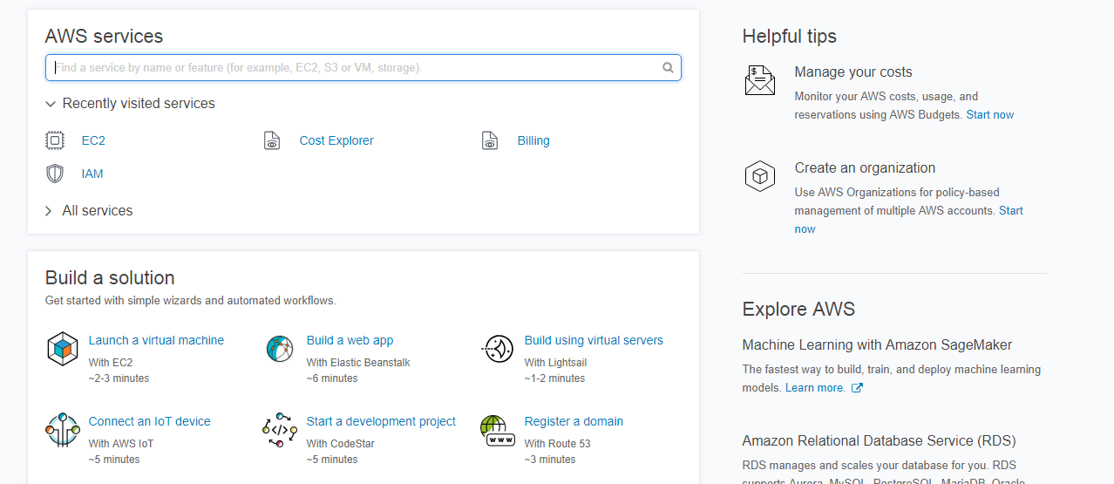

1. Now, go to services 🡪 EC2.

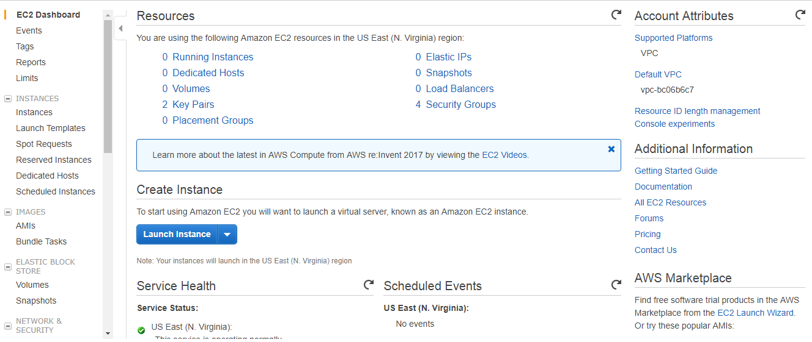

1. Now, click on Launch Instances or go to Instances 🡪 Launch Instance

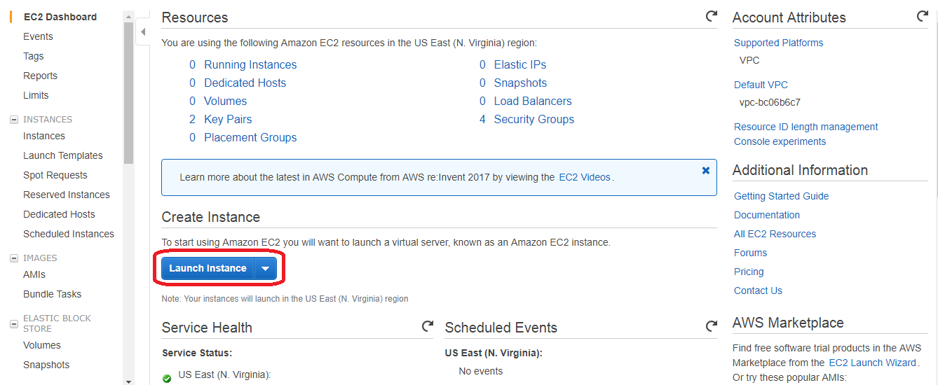

1. Now, choose the ami image (or else choose with OS, Architecture and Root Device type) you need to create. I am choosing ami id# ami-d05e75b8.

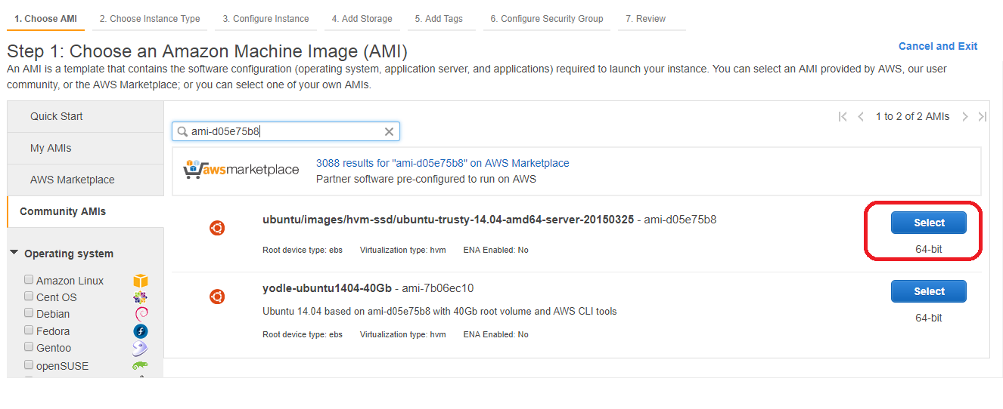

1. Now, select “Instance Type”. (Choose minimum “t2.medium”)

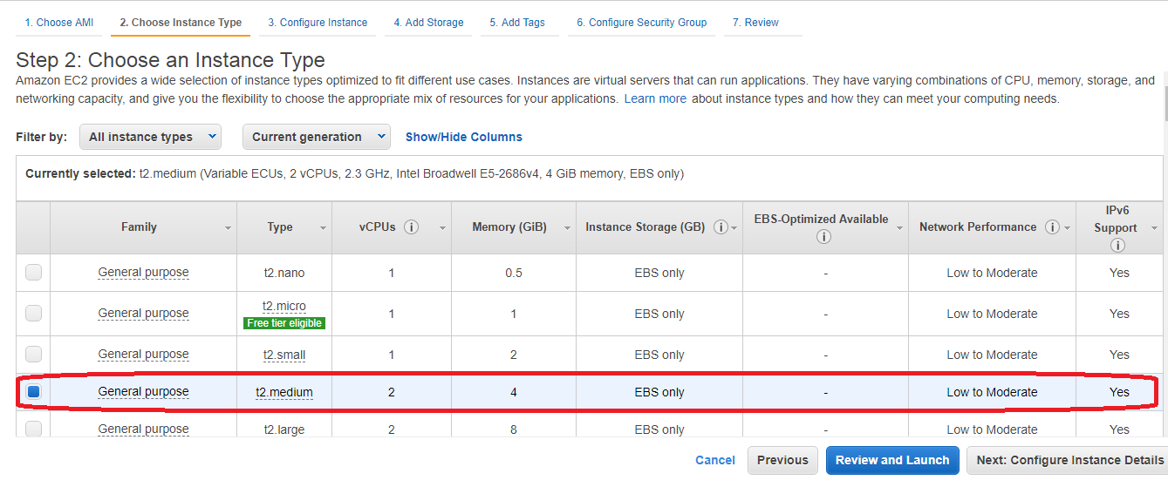

1. Now, click on “Next: configure Instance Details”

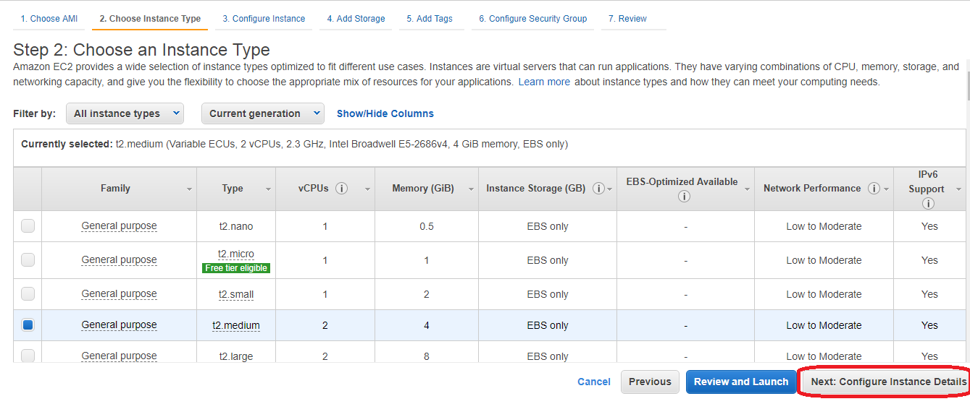

1. Now, select number of instances (the number may vary from requirement to requirement). But choose minimum 5 instances.

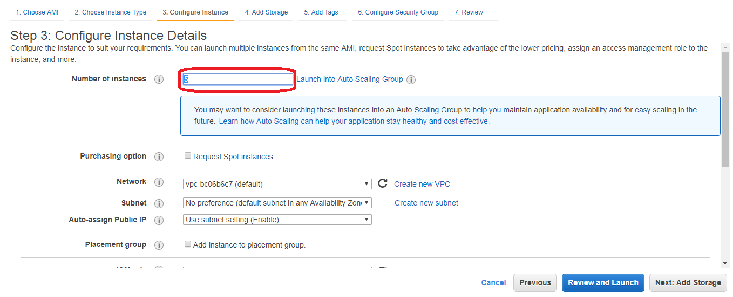

Note: Select the check box before “Request Spot Instances” for better pricing.

1. Now, click on “Next: Add storage”.

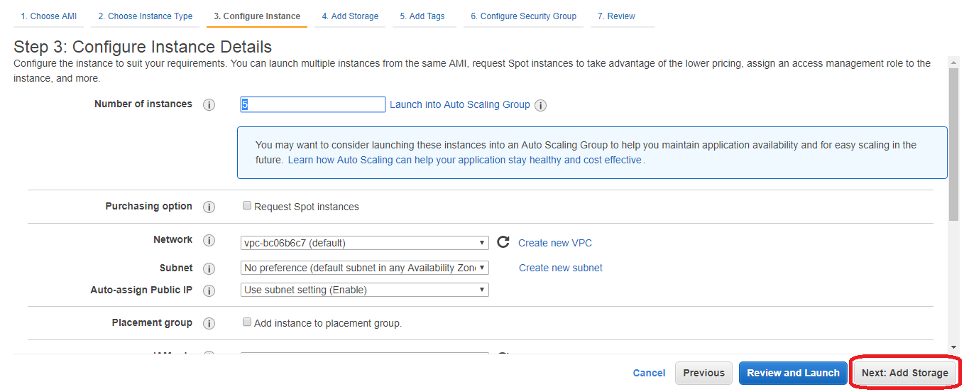

1. Now, choose the HDD size in GigaByte. It depends on the size of the data you need to store in the cluster. (Note: Please give HDD size greater than 20 GB).

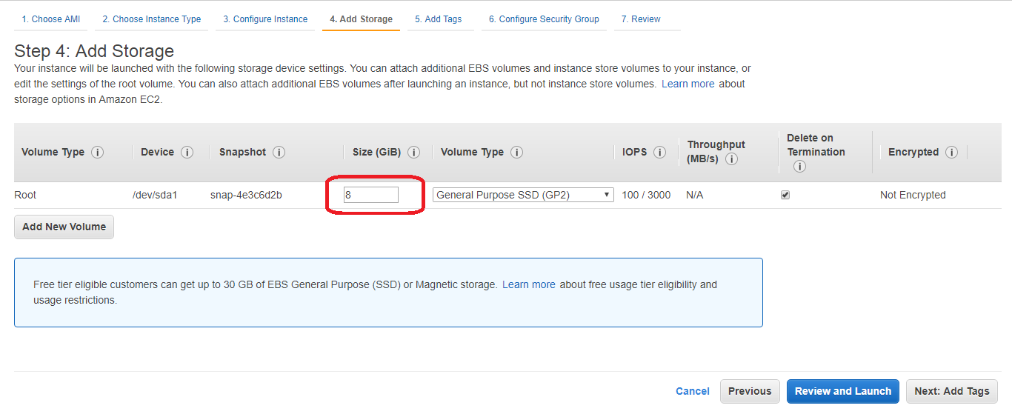

1. Now, click on “6. Configure Security Group”

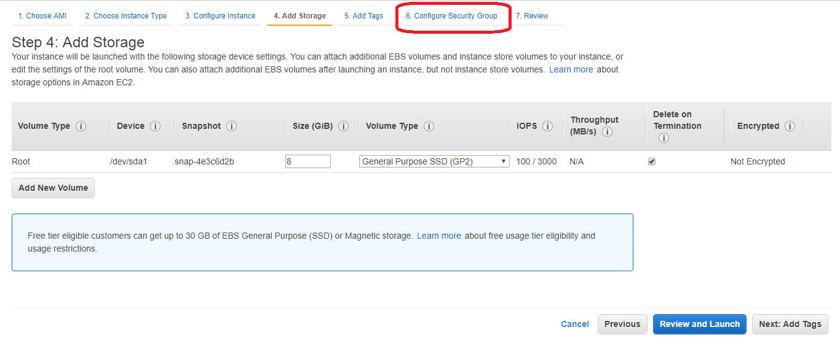

1. Select “Create a security Group” check box. And give proper security group name and description. Now, add two rules “All TCP”, “All ICMP IPv4” with Source “Anywhere”.

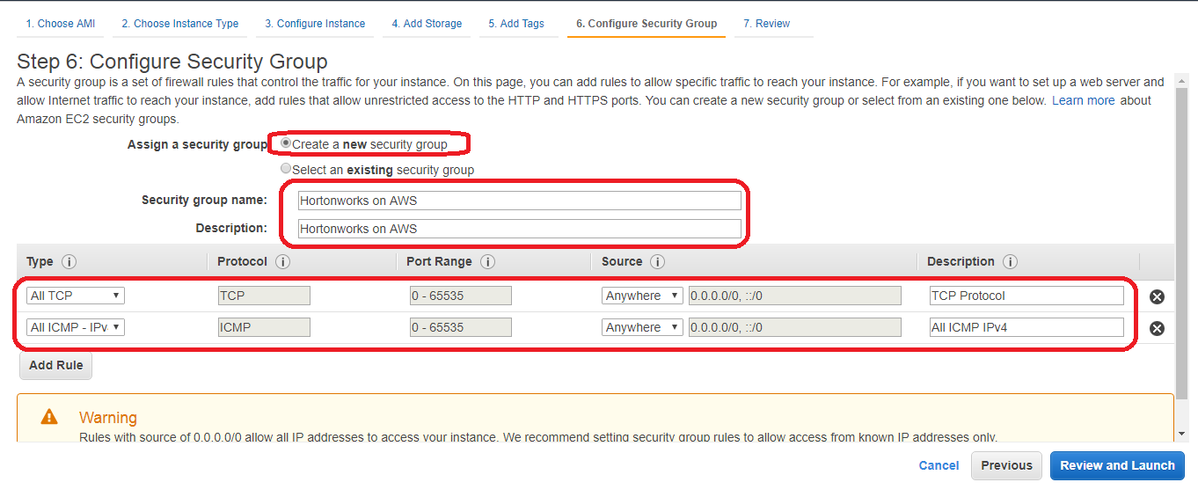

1. Now, click on “Review and Launch”.

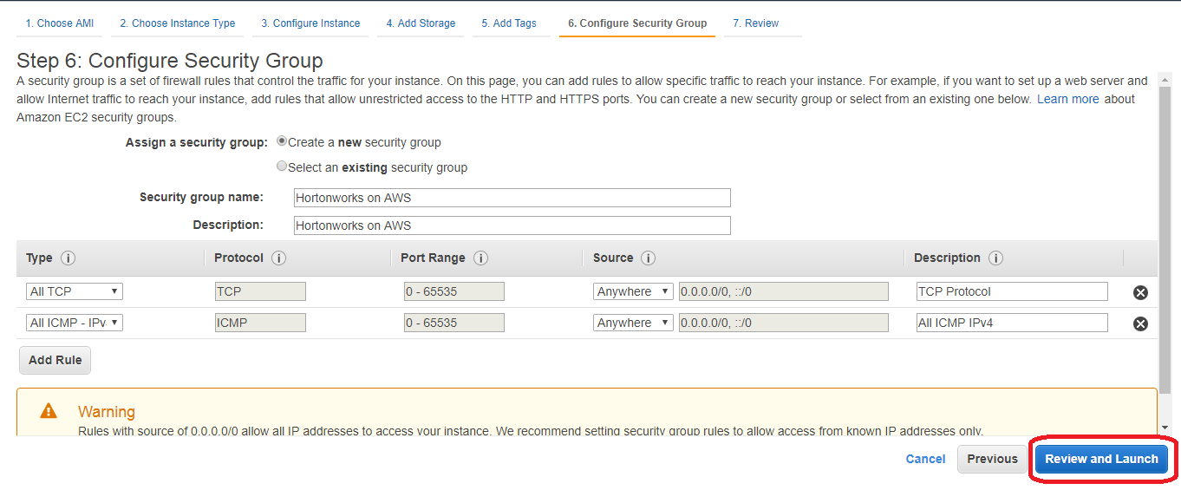

1. Verify all the details once again and click on “Launch”.

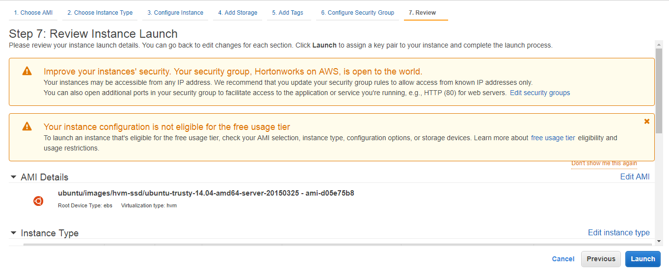

1. Now, choose “Create a new key pair” and give Key pair name. And click on “Download Key pair”.

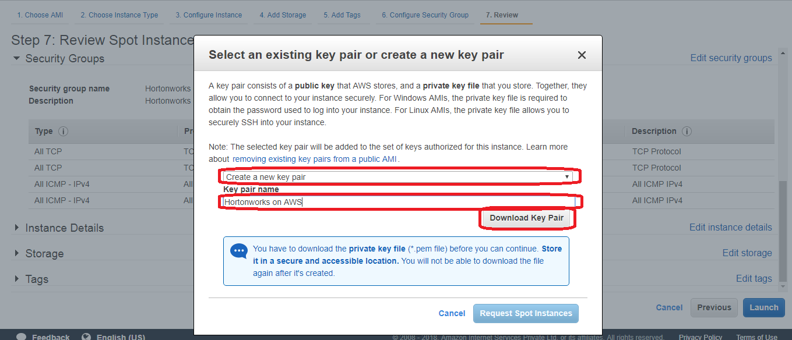

**Note:** if you lose the key pair file, you can’t log in to AWS cluster. So, store the key pair file in a secured location.

1. Click on “Launch Instances”

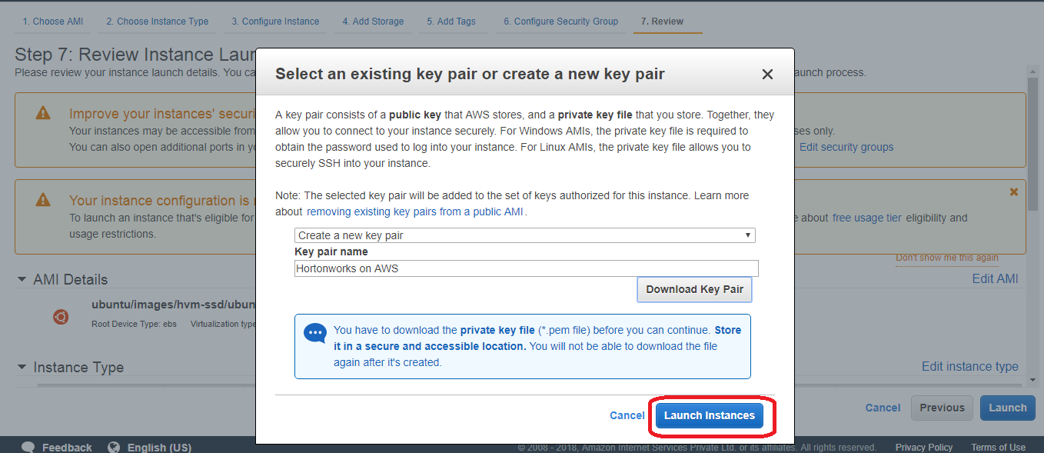

1. You will get a successful message saying that your instances are running. Now, click on “View Instances” .

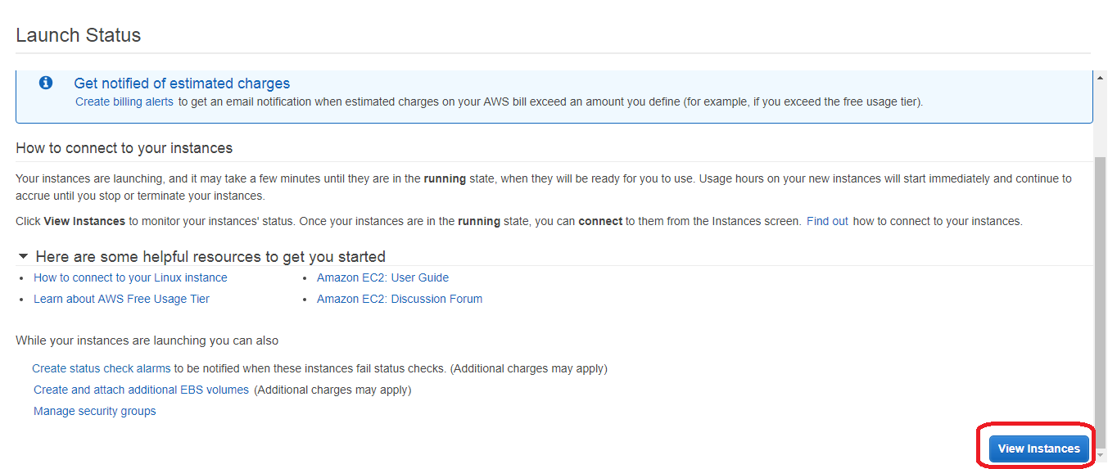

1. Wait for some time, so that all the instances are in running state.

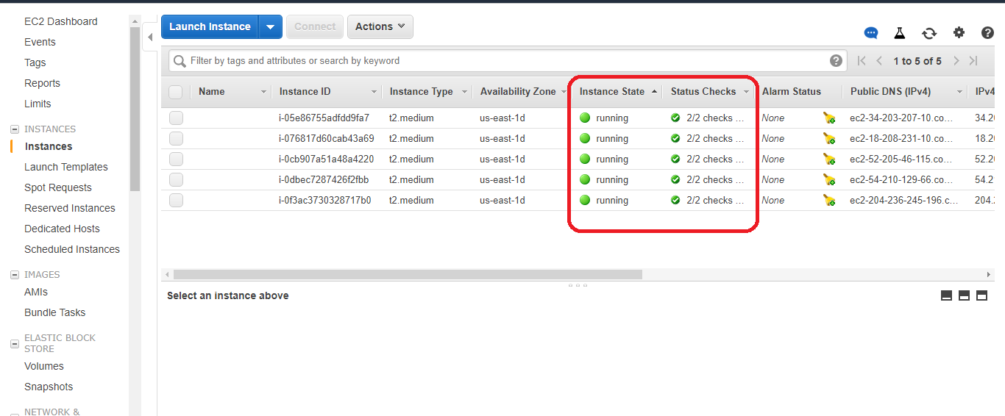

1. Now, download “Puttygen.exe” application from [www.putty.org](http://www.putty.org).
2. Open Puttygen.exe

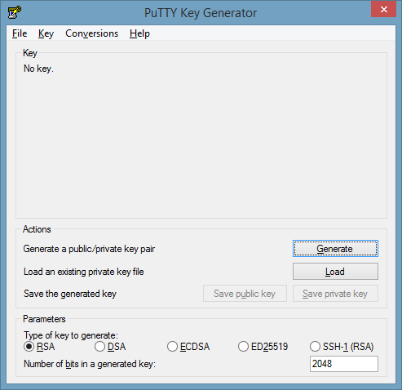

1. Now, click on “Load” and select the key pair (*.pem) you have downloaded the step 14. While selecting, click on all files.

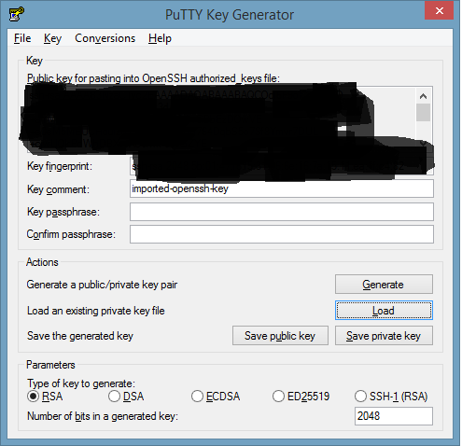

1. Now, click on “save public key” and save public key.
2. Similarly, click on “Save private key” and save private key with extension .ppk
3. Now, copy all the EC2 instances public IP addresses and private DNS names in a notepad file.
4. Now, open putty.exe.
5. In Hostname, give any one public IPaddress of EC2 instance and port number as 22. And expand SSH on left panel and select Auth.

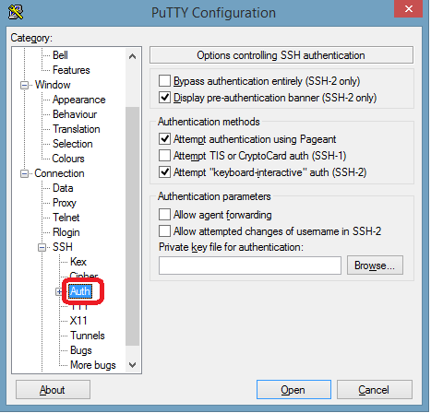

1. Now, browse for the private key file which you have generated in the step 22. And click on Open button.

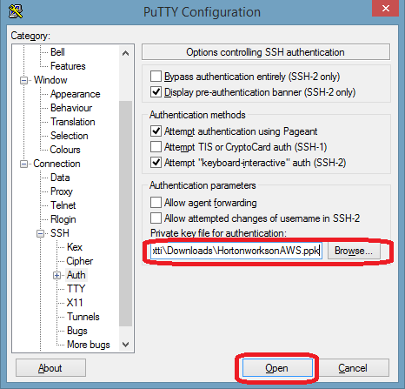

1. Click on Open button. And select Yes on Putty security popup window.

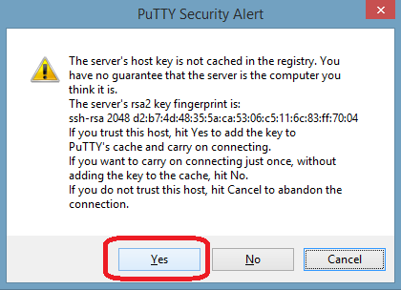

1. Give the user name as “ubuntu” and click on enter button. Putty won’t request for the password, as we are logging into EC2 instance by Key pair authentication.

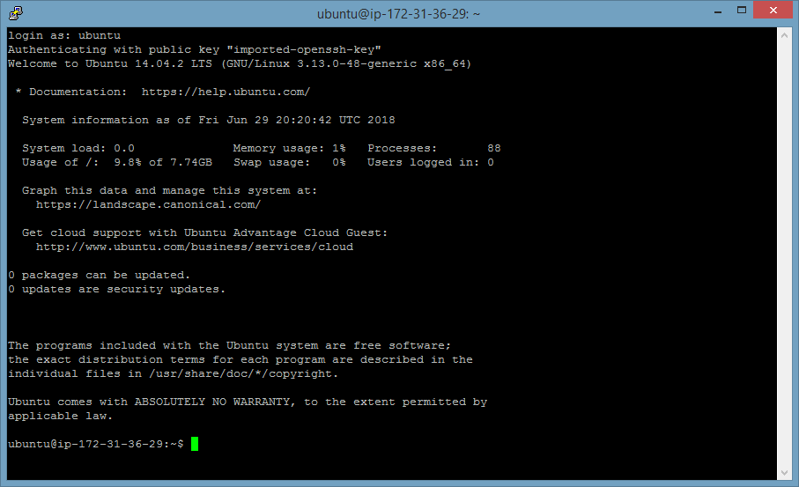

1. Install Amabi application in the EC2 instance.
   1. Now change the user from ubuntu to root to install ambari application with the command give below “sudo su root”

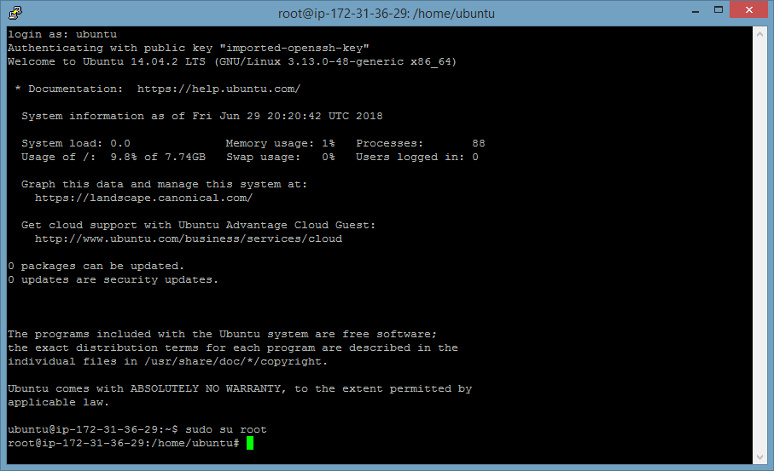

* 1. Now, enter the below command “cd /etc/apt/sources.list.d”

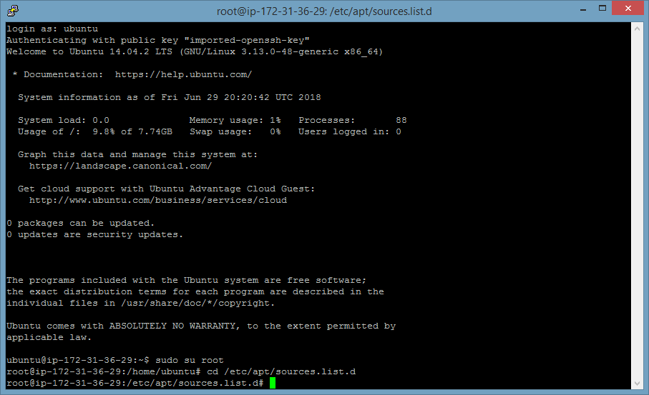

* 1. Now, enter the below command to download the ambari application list.

wget <http://public-repo-1.hortonworks.com/ambari/ubuntu14/2.x/updates/2.2.2.0/ambari.list>

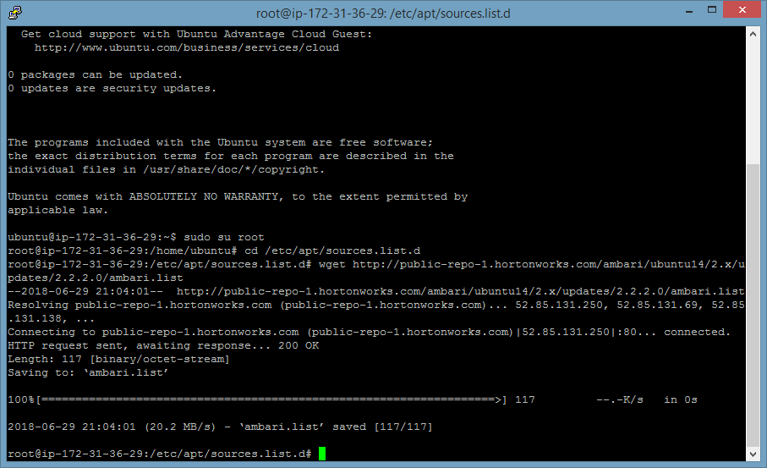

* 1. Now, execute the below command:

apt-key adv --recv-keys --keyserver keyserver.ubuntu.com B9733A7A07513CAD

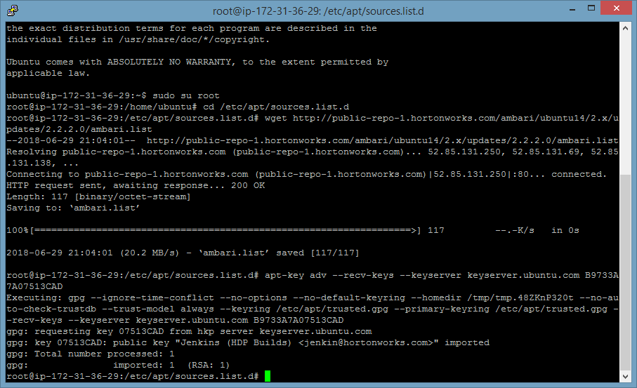

* 1. Now, execute the below command to update the ambari application.

apt-get update

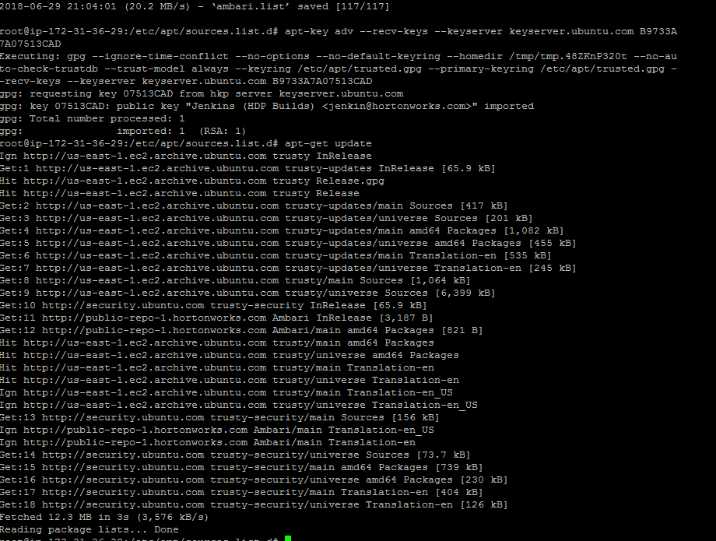

* 1. Now, execute the below command:

apt-get install ambari-server

* + 1. Now, you will be requested to press “Y” to continue.

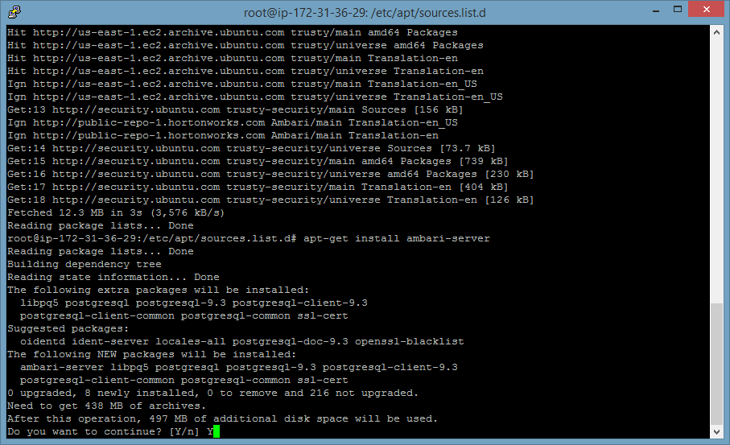

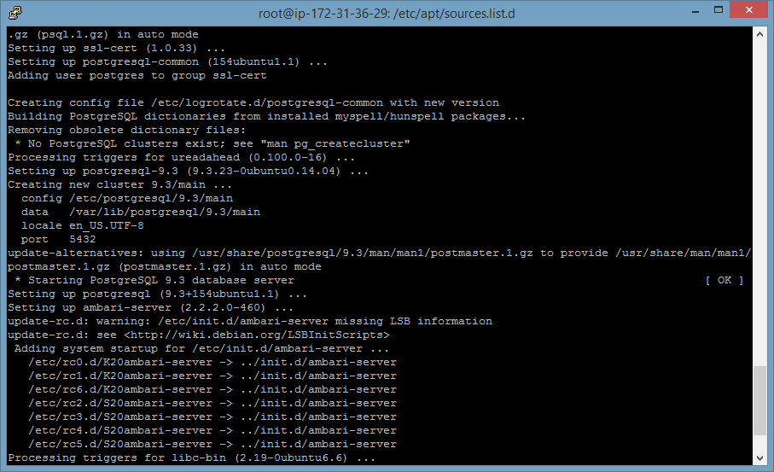

* 1. Now, execute the below command:

ambari-server setup

Say “n” to Customize user account for ambari server daemon.

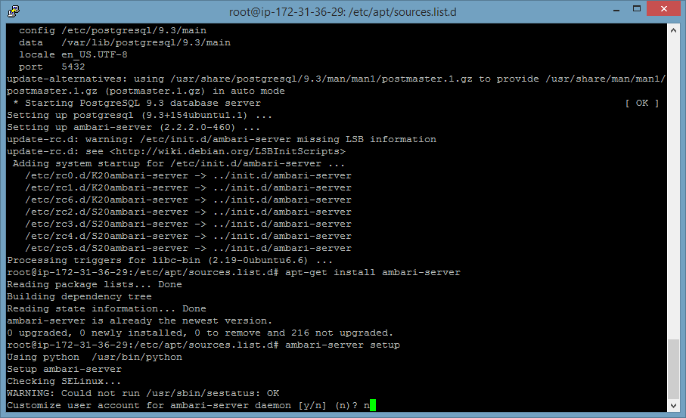

Say 1 to install oracle JDK 1.8 version.

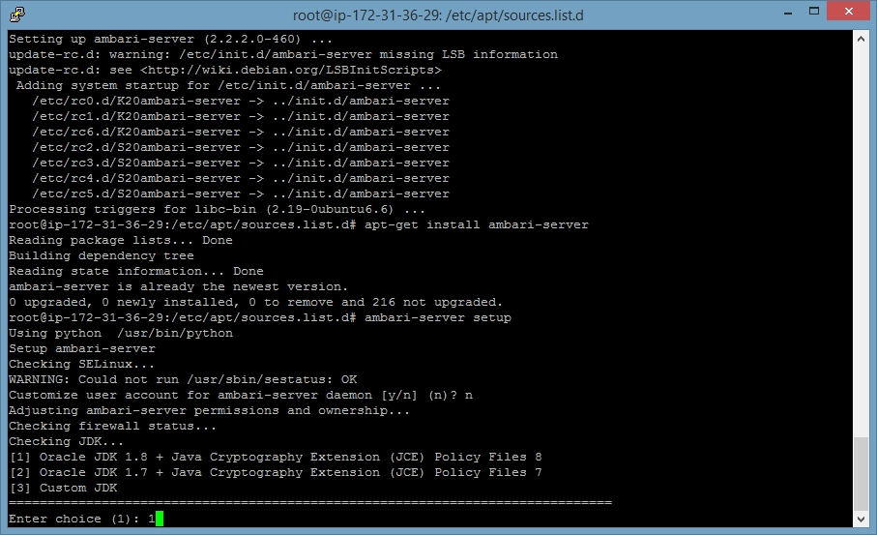

Say “y” to Oracle Binary code license agreements.

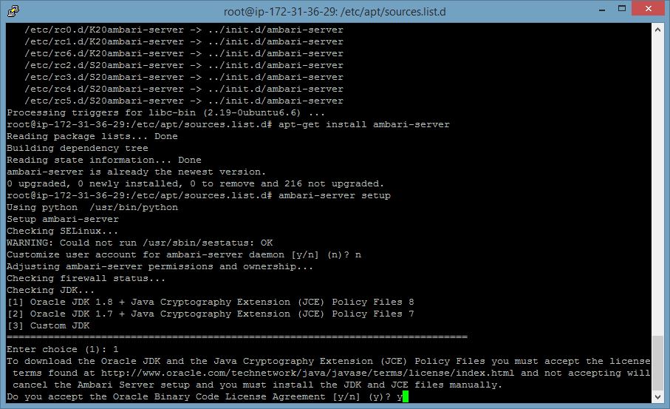

Say “n” to advanced database configuration.

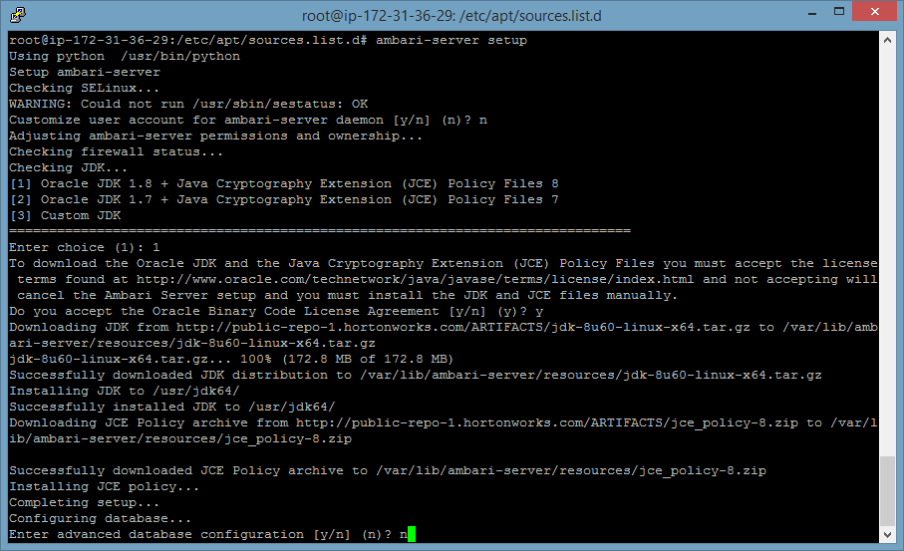

* 1. Now, execute the below command to start the ambari server:

ambari-server start

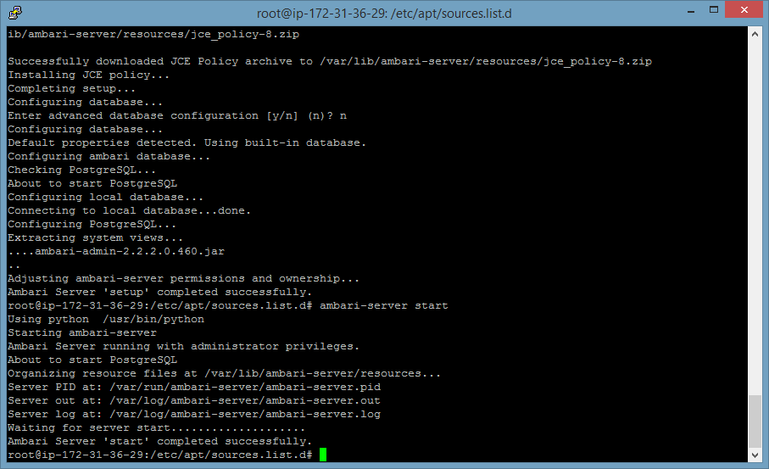

1. Now, open the URL# in the web browser. And username and password both are admin.

Public ip address of EC2 instance (where we installed the ambari server):8080

Ex: xx.xx.xx.xx:8080

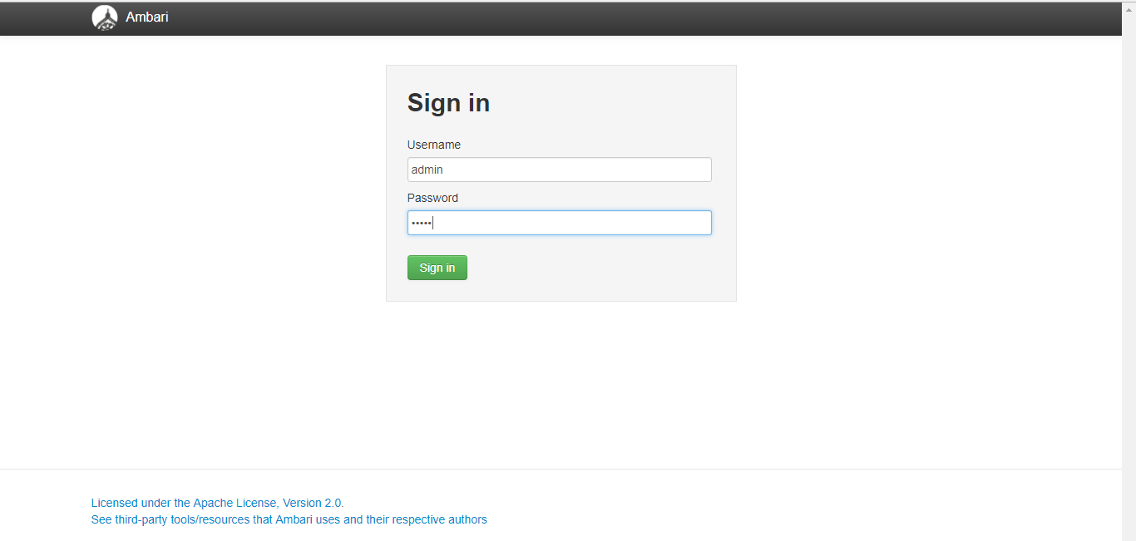

1. Now, click on “Launch Install wizard”

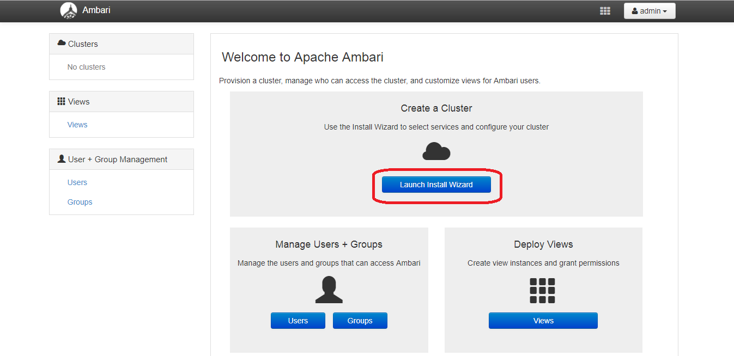

1. Give the proper cluster name and click on Next button.

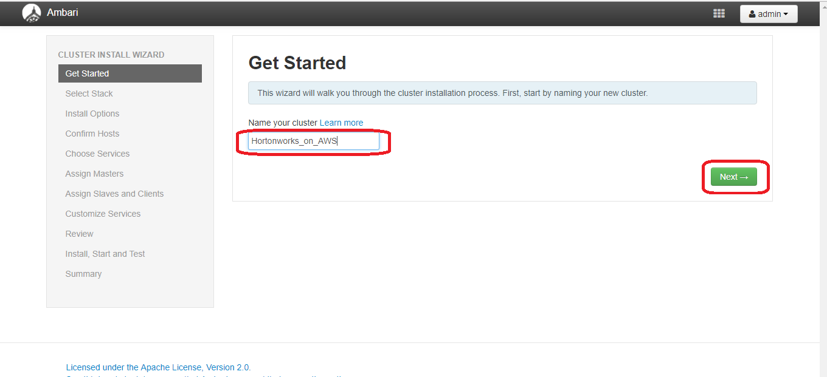

1. Select the appropriate Hortonworks Data Platform (HDP) version and click on Next button.

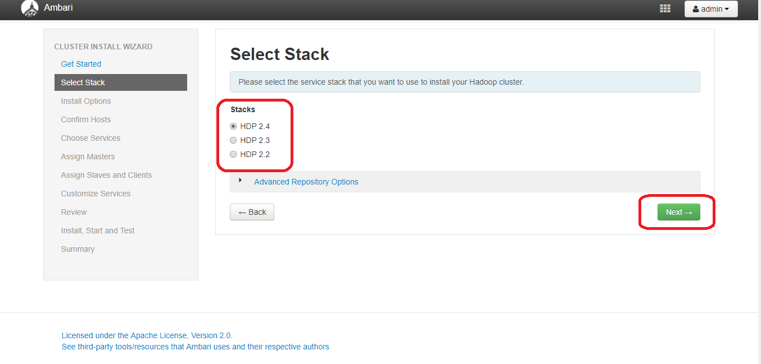

1. Now, copy the other 4 EC2 instances private DNS names and paste them under Target Hosts. And select the key pair file (which you have downloaded in the step 14.) under “Host Registration Information”. And change the SSH user account to “ubuntu”.

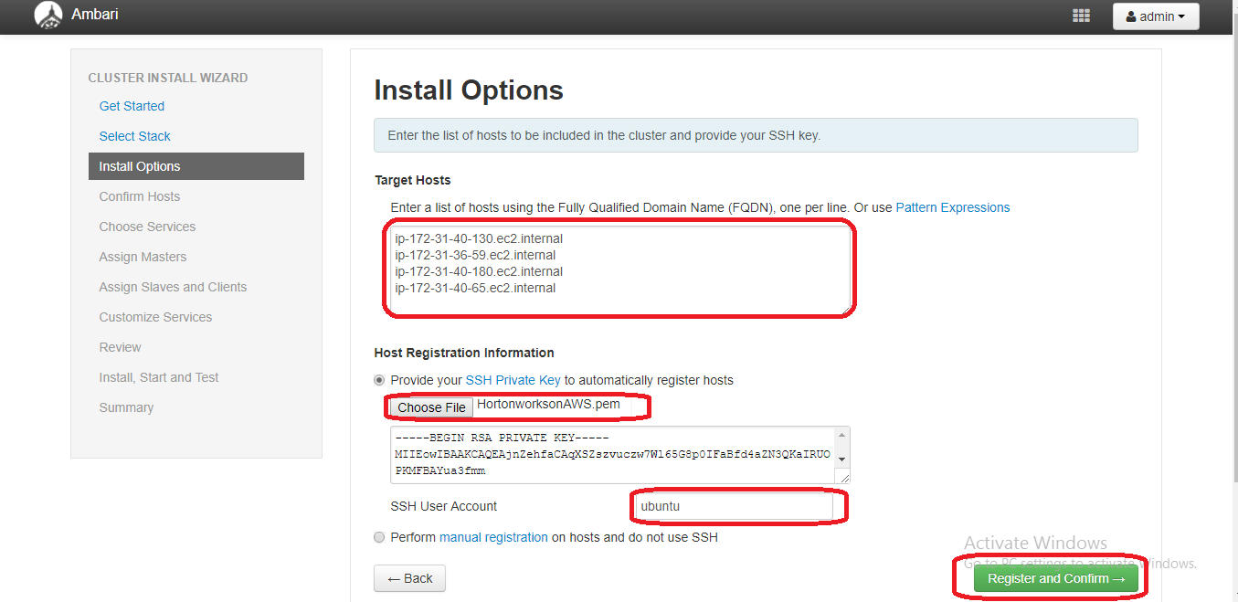

1. Once the progress completed and status displayed as “Success”, click on “Next”.

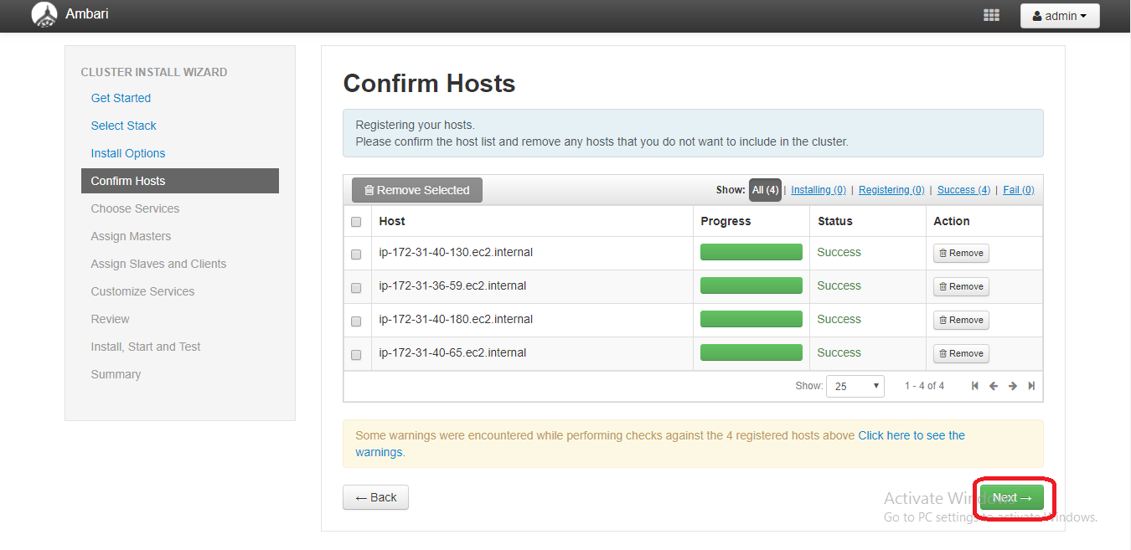

1. If you choose less HDD space, you will get the below warning. You can ignore it.

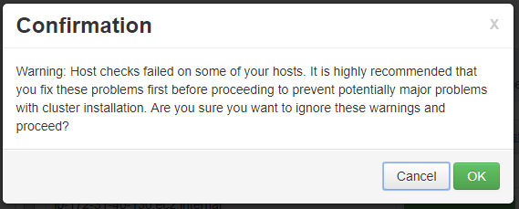

1. Now, choose the appropriate Hadoop applications you need to run on Hortonworks cluster. And click on “Next”.

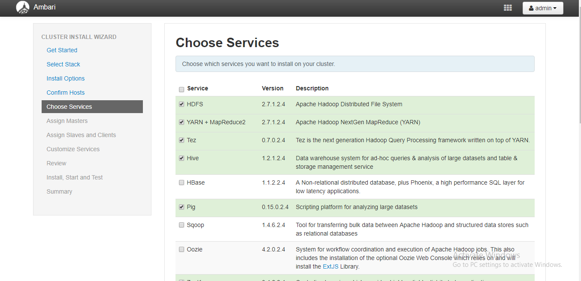

1. Now, assign the master components to hosts and click on “Next”.

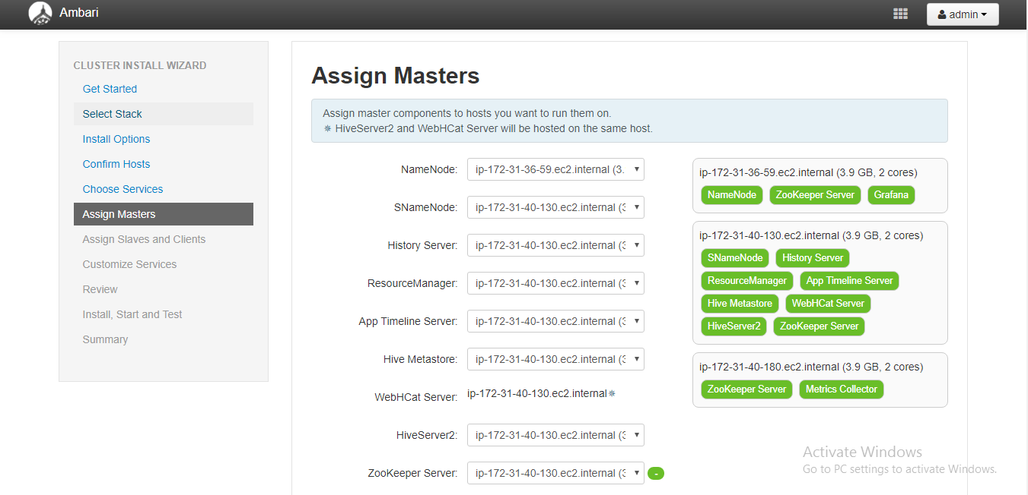

1. Now, assign the slave and client machines to Hosts and click on Next button.

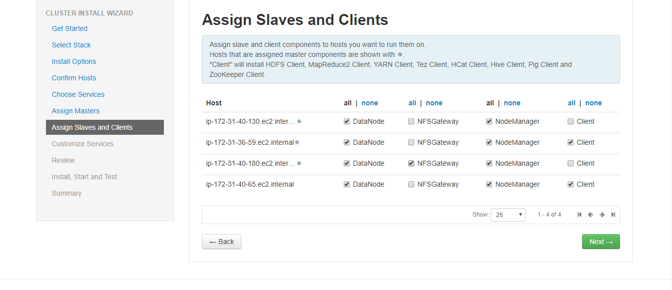

1. Under “Customize Services”, Hive 🡪 Advanced, please provide the new database password. Similarly provide the new passwords for other applications also. (Please note these passwords secretly). And click on “Next”.

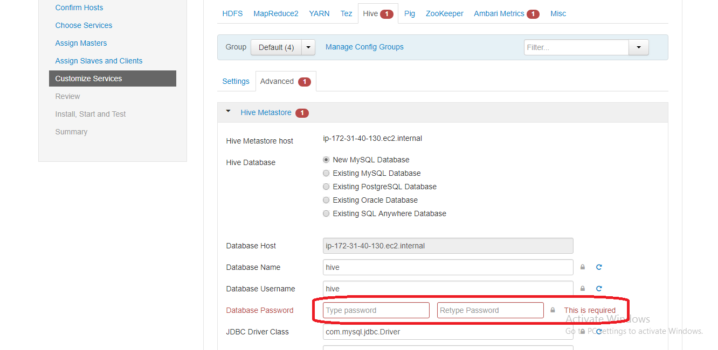

1. If you choose less HDD space (In Step 9), you will get this warning. You can click on “proceed Anyway” but, we can’t guarantee that all processes will start properly.

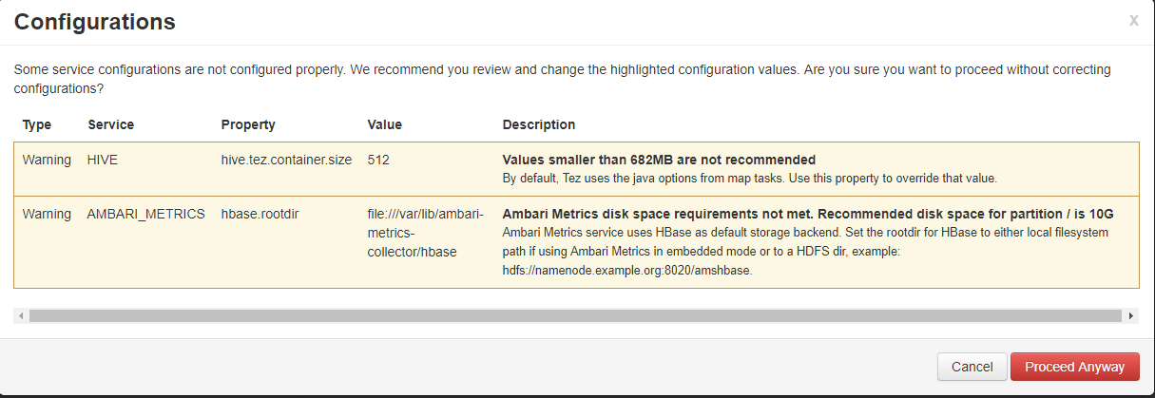

1. Now, you can click on “Deploy”.

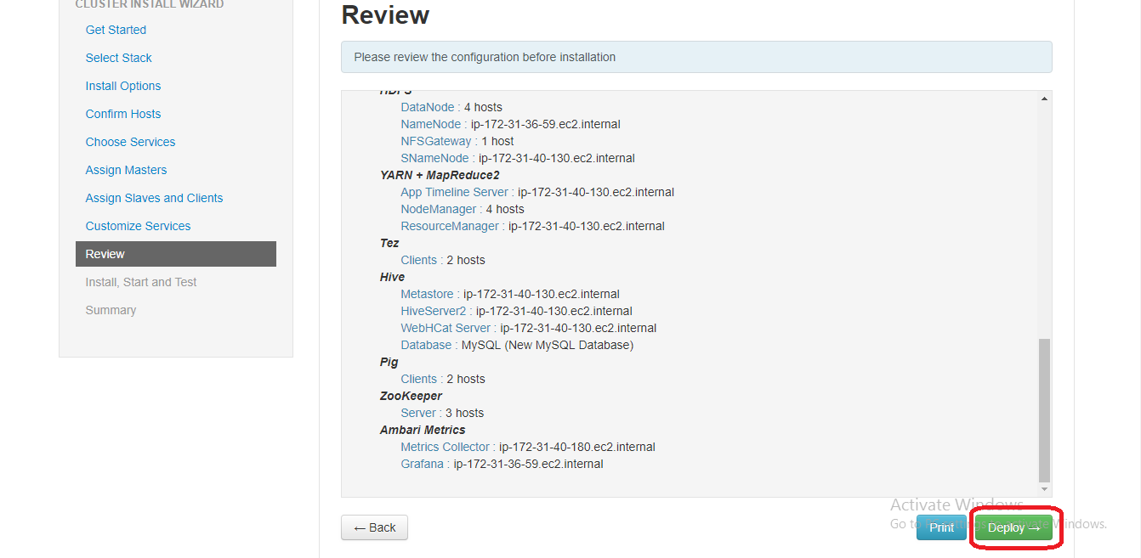

1. Now, you can see that all the selected applications are installing in the 4 EC2 instances.

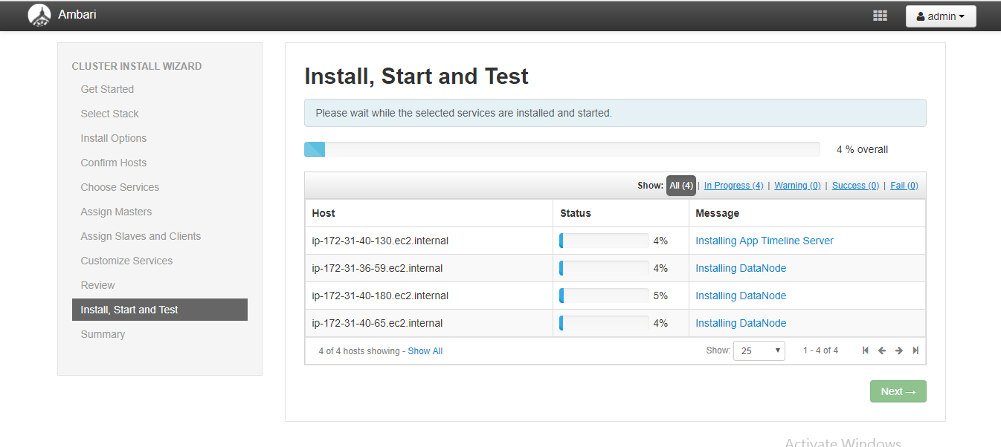

1. Once all the applications installed successfully, click on “Next”.

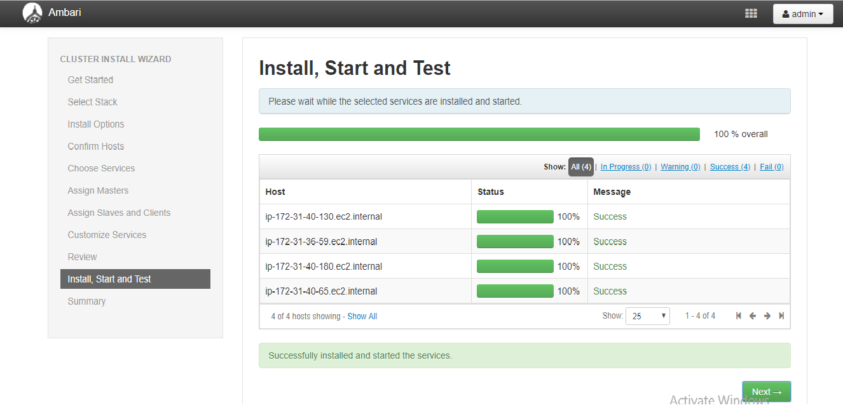

1. Now, you will get the summary of the applications you have installed on EC2 instances. And click on “Complete” to proceed further.

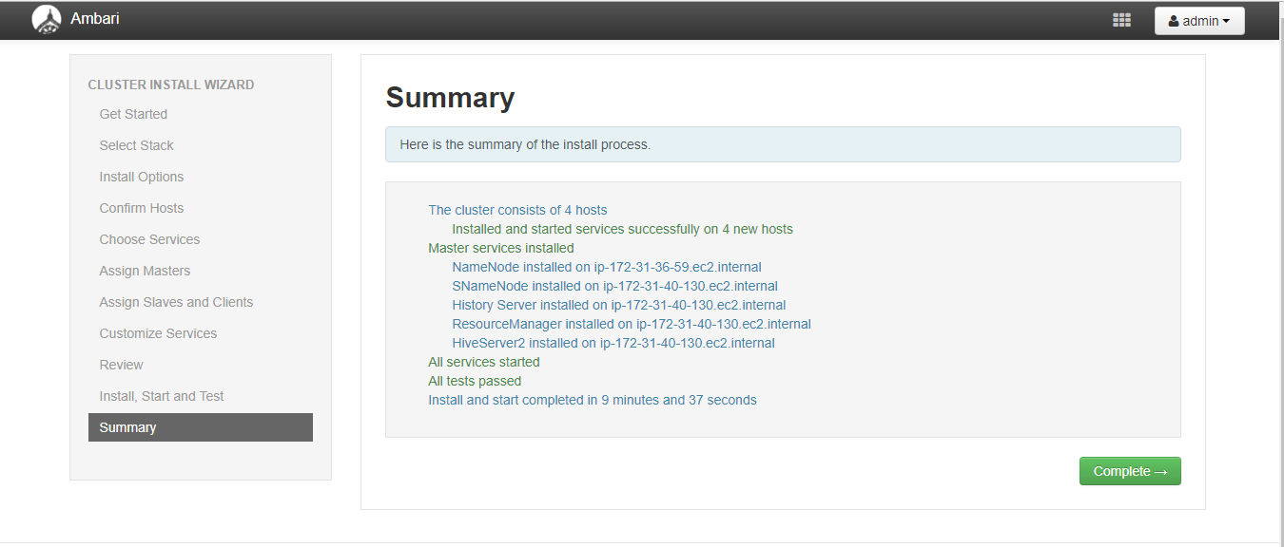

1. Now, you can see all the applications are successfully installed and in running state.

